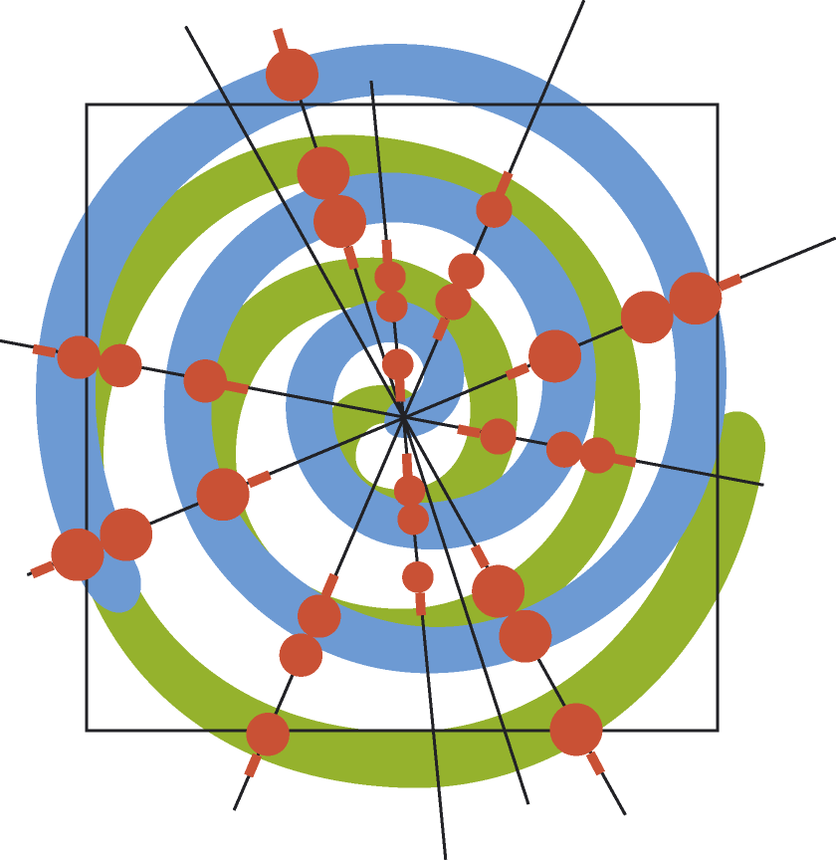
Address of Recipient: | IMP – UNI

ANIMAL TRANSFER AGREEMENT

I.M.P. agrees to provide the “RECIPIENT” with the following transgenic or mutant animal(s)

………………………………………………

as requested per letter dated ............................................................. for the sole purpose to conduct the experiments outlined in the letter dated …………………………….. (copy enclosed). I.M.P. will send the requested transgenic or mutant animal(s) [hereinafter called “Animals and/or Material(s)”] after having received a signed copy of this Animal Transfer Agreement.

The following is agreed upon:

1. The “RECIPIENT” may not distribute the “Animal(s) and/or Material(s)”, or any
(i) animal developed by, through or with the use of such “Animal(s) and/or Material(s)” and/or
(ii) zygotes, embryos, cells, tissues, fluids, genetic material, proteins or other compounds derived or recovered from the “Animal(s) and/or Material(s)” or any other animal referred to in (i) whether or not such recovery or derivation involves further processing, culturing, purification, manipulation, formulation or other such steps, or any biological material derived from that biological material through propagation or multiplication in an identical or diverging form,
to any other person or entity to use them without prior written permission from the I.M.P.

2. The “Animal(s) and/or Material(s)” or any other animal referred to in point (1) remain the property of I.M.P.

3. No studies other than those specifically outlined in the aforementioned request for the “Animal(s) and/or Material(s)” will be conducted without the prior written consent of I.M.P.

4. The “Animal(s) and/or Material(s)” may be used solely for non-commercial research purposes. NO DATA OBTAINED FROM OR THROUGH THE USE OF SUCH “ANIMAL(S) and/or MATERIAL” WILL BE USED FOR DIAGNOSTIC OR CLINICAL PURPOSES ON HUMANS.

5. Wherever reasonable, the “RECIPIENT” has considered in vitro approaches to the research and has followed the relevant legal regulations on animal trials.

6. Any patent application relating to (an) invention(s) based on results of investigations involving the use of the “Animal(s) and/or Material” will be in cooperation with I.M.P.

7. I.M.P. and its shareholder and its affiliates are hereby granted a right of first refusal to commercialize any substance, “Animal(s) and/or Material” produced or isolated with or by use of the “Animal(s) and/or Material(s)” under terms to be negotiated in good faith.

8. I.M.P and its shareholder and affiliates are hereby granted a non-exclusive, royalty-free license to any discovery or invention relating to a new use of the “Animals and/or Materials” generated through “RECIPIENT’s” research with the “Animal and/or Materials”.

9. The “RECIPIENT” accepts the Animal(s) with the knowledge that they are experimental in nature and that they are provided by I.M.P “as is” without warranty of any sort, expressed or implied. The “RECIPIENT” agrees to hold I.M.P. harmless from any damages which may be alleged to result in connection with your use and possession of the requested Animals.

I.M.P. would greatly appreciate if the “RECIPIENT” could inform it about the results of research in connection with the material; in particular about any data which result in a publication or oral presentation, e.g. data referring to the elucidation of biological mechanisms involving the material, the discovery of novel characteristics or activities of the material.

Such data may represent or lead to patentable subject matter. It would therefore be to the advantage of the “RECIPIENT” to seek the advice of I.M.P. on this well in advance before making findings available to the public.

BRC will ship the material upon receipt of the signed document.

BRC will send the signed document to

RESEARCH INSTITUTE OF MOLECULAR PATHOLOGY GmbH
A-1030 Vienna,
Dr. Bohr-Gasse 7
AUSTRIA

Done in duplicate

Recipient Institution (Name and Address)

______________________________

_____________________________ ________________________
Name of authorized Official Title of authorized Official

______________________________ _________________________
Date Signature of authorized Official

I.M.P. stands for RESEARCH INSTITUTE OF MOLECULAR PATHOLOGY GES.M.B.H., Dr. Bohr Gasse 7, A-1030 Wien
"Affiliates" in relation to Boehringer Ingelheim GmbH (BIG) shall mean any corporation or other business controlled by BIG, controlling the BIG, or under common control with the BIG, "control meaning the ownership, directly or indirectly, of fifty percent (50%) or more of the voting shares or, in the absence of ownership of more than fifty percent (50%) of the voting share capital of the company, the power to control the composition or activities of its board of directors.

